**Reflection of Week-4 lab work**

**This lab was to focused on REST API methods work in express framework. In this lab, I learned to create JSON file and read the file using Node.js built in fs module with express. As long as I followed the steps with the help of tutor, it was easy to understand and learn. Similarly, I learned to run the code in the server and get desired output from the server. I followed the steps one by one carefully, which made easy to code but in one point there was small mistake in the given which I solved easily.**

**In this lab, we did different exercises. In the first exercise, I wrote a simple code in index.js using express framework and run the code in the browser. The Output of first exercise is** 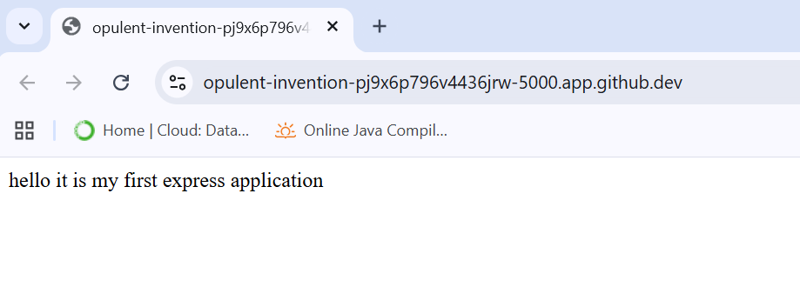

**In the Second exercise, I added some code in index.js to get the following output after adding /about in the url in the search bar.**

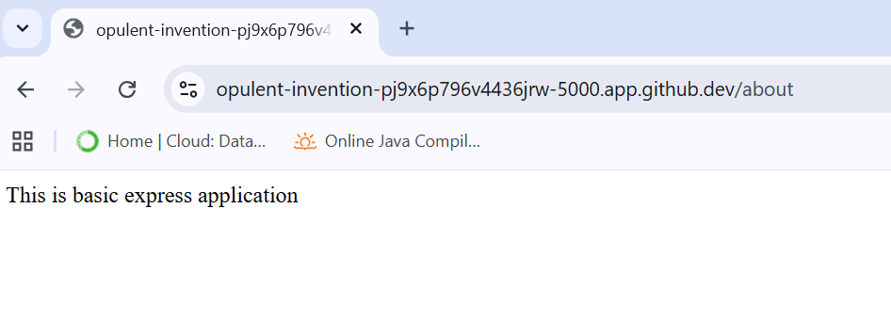

**Similarly, results of /users/33/books/123 and users/334/books/143**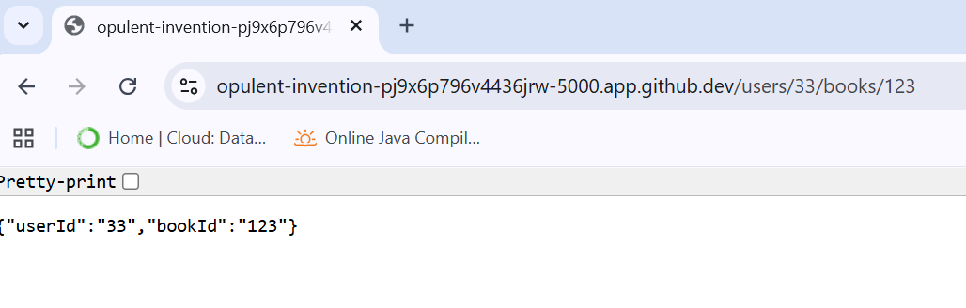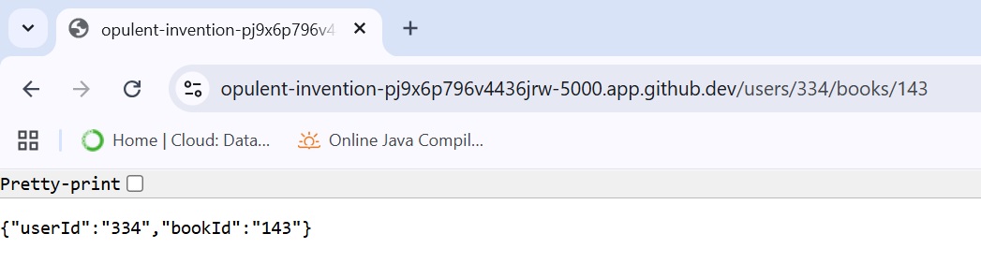

**In exercise three, I created another file called Student.json and adding some data in it. I added some code in index.js file as given. The result of it is given below.** 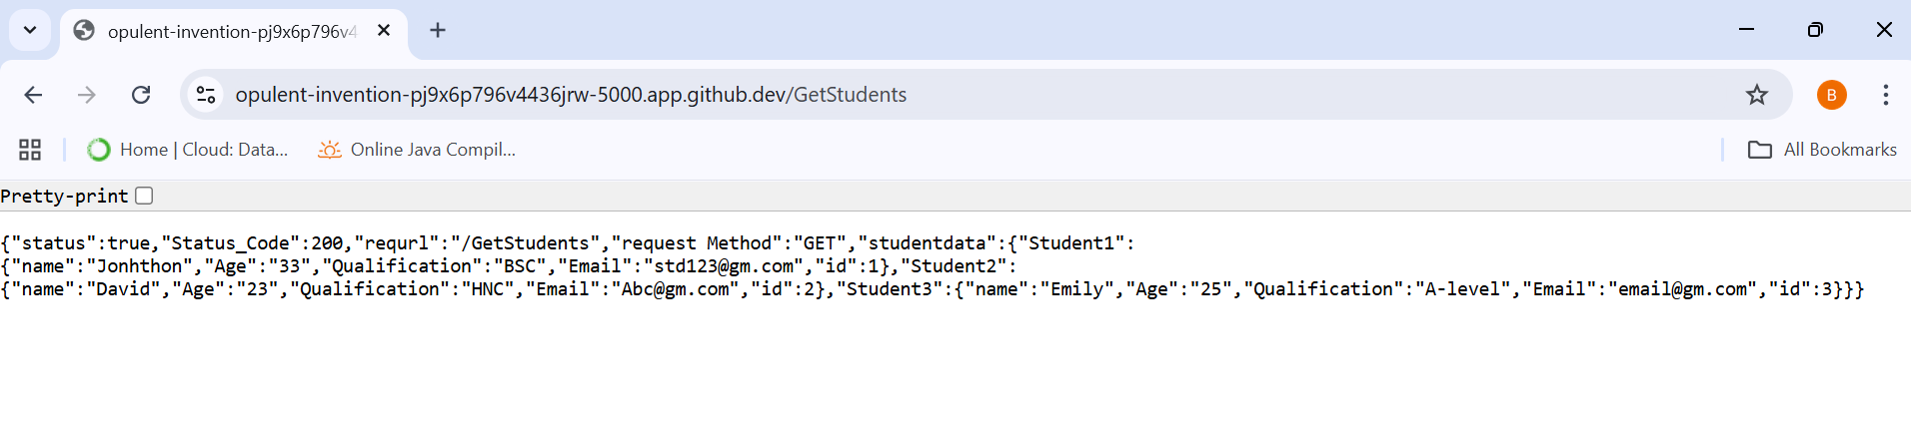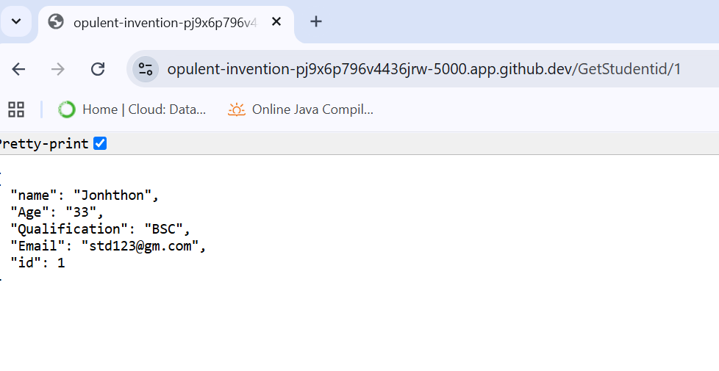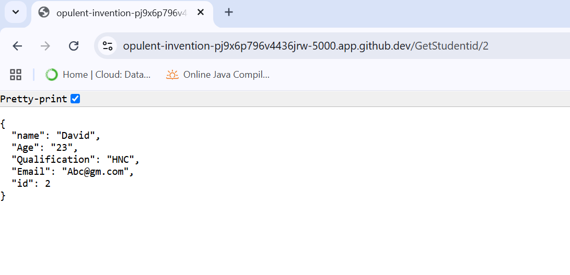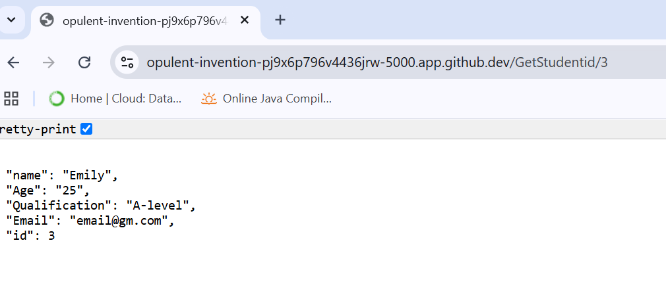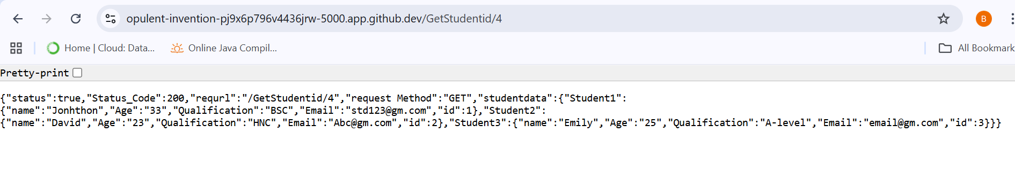

**Finally, In exercise 4 I create html file called StudentInfo.html to create form to take student information and display in the browser using Post Method. The final result of thisexercise is given below after submitting student information**.